Complete NoSQL Lab Manual
MongoDB + Neo4j Installation & Hands-On Exercise
(For Existing WSL Ubuntu Environment)

PART 1: MongoDB Installation in WSL (10 minutes)
Step 1.1: Update Ubuntu Packages
bash
sudo apt update && sudo apt upgrade -y
Step 1.2: Install Required Dependencies
bash
sudo apt install curl wget gnupg lsb-release -y
Step 1.3: Import MongoDB Public Key
bash
curl -fsSL https://www.mongodb.org/static/pgp/server-8.0.asc | sudo gpg -o
/usr/share/keyrings/mongodb-server-8.0.gpg --dearmor
Step 1.4: Add MongoDB Repository
bash
echo "deb [ arch=amd64,arm64 signed-by=/usr/share/keyrings/mongodb-server-
8.0.gpg ] https://repo.mongodb.org/apt/ubuntu noble/mongodb-org/8.0 multiverse" |
sudo tee /etc/apt/sources.list.d/mongodb-org-8.0.list
Step 1.5: Install MongoDB
bash
sudo apt-get update
sudo apt-get install -y mongodb-org
Step 1.6: Start MongoDB Service
bash
sudo service mongod start
Step 1.7: Verify MongoDB is Running
bash
sudo service mongod status
Expected Output: active (running)
Step 1.8: Test MongoDB Connection
bash
mongosh --eval "db.runCommand({ping: 1})"
Expected Output: { ok: 1 }
Step 1.9: Start MongoDB Shell (Keep this open for Part 3)
bash
mongosh
You should see: test>
ScreenShot:
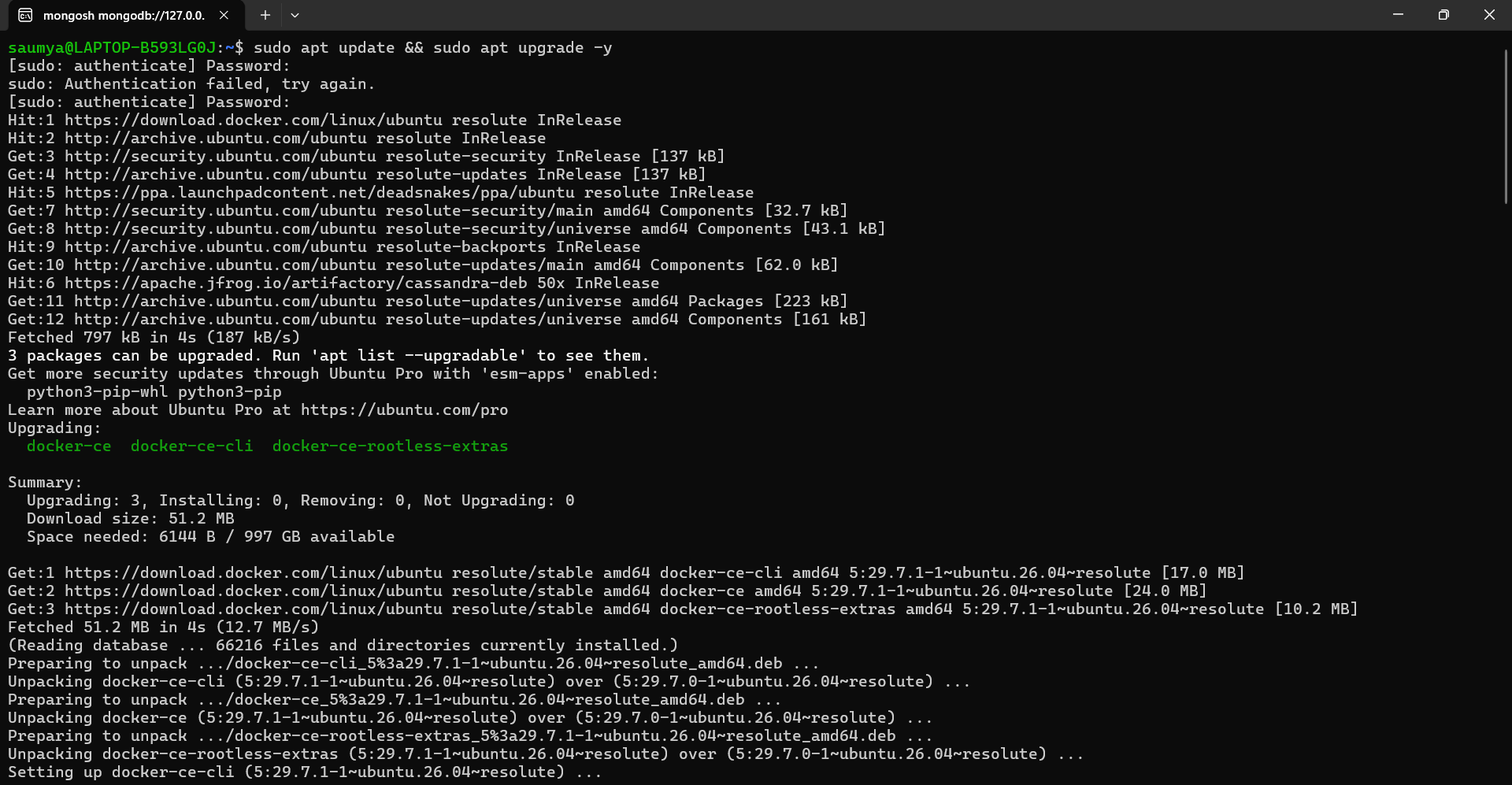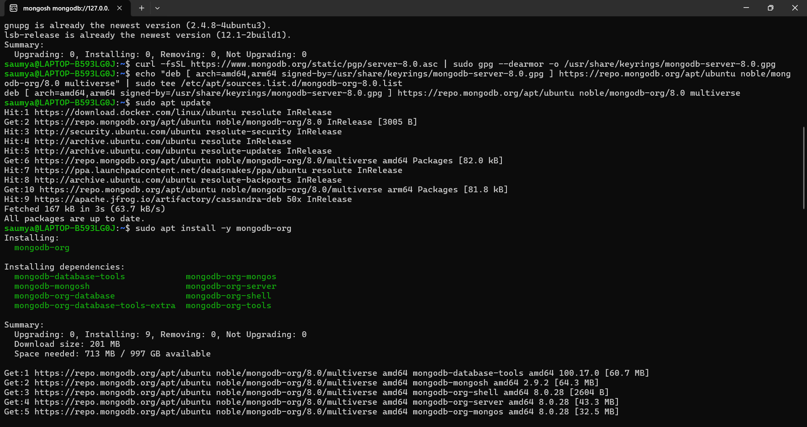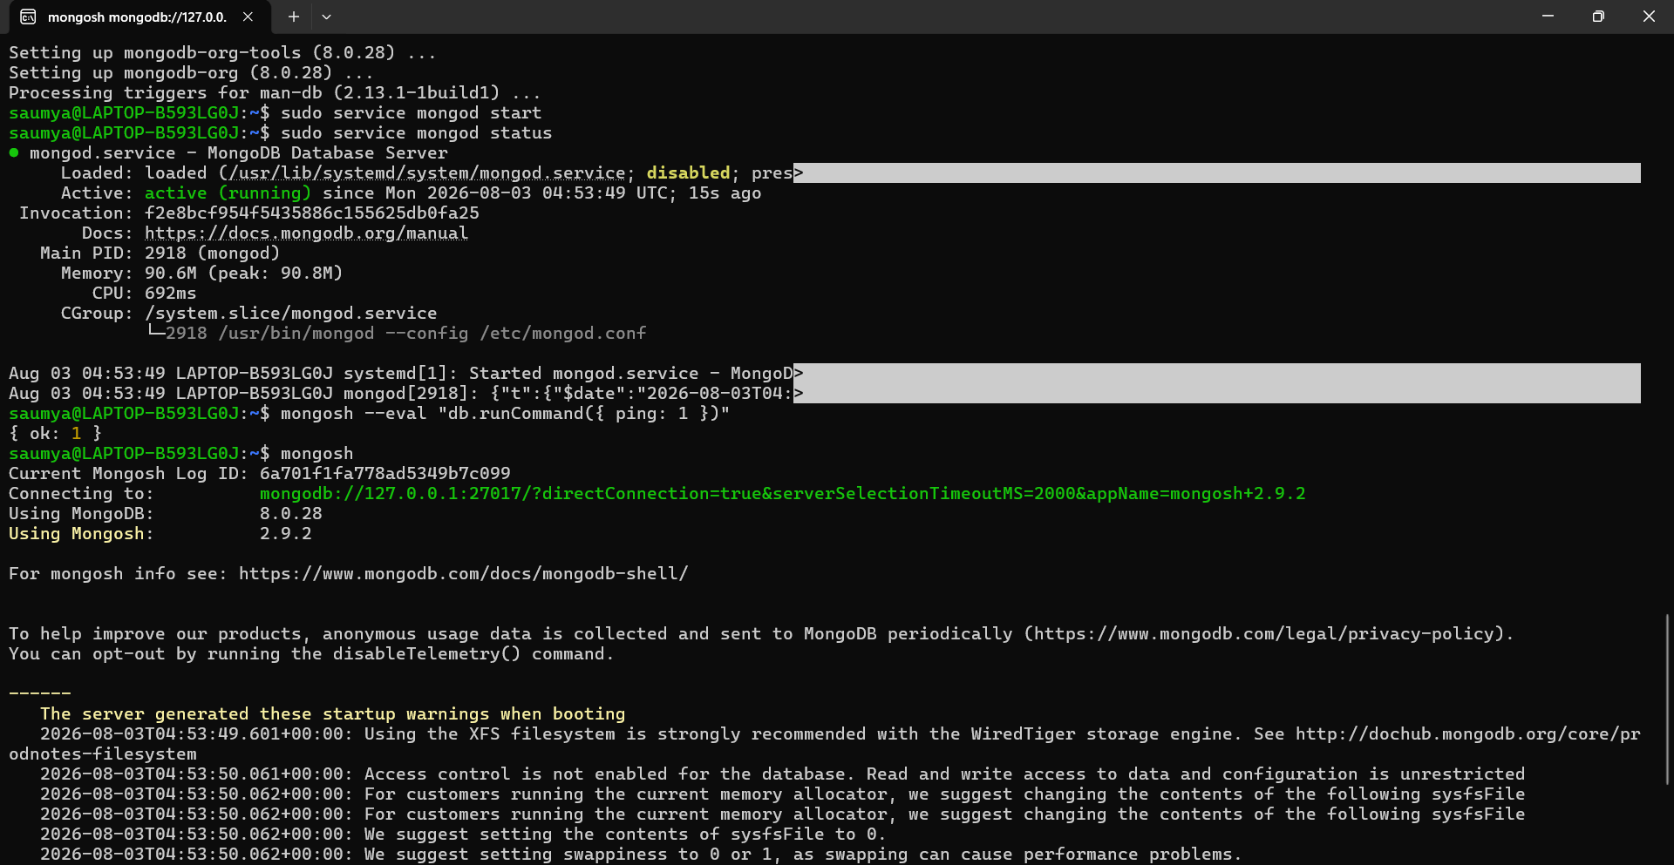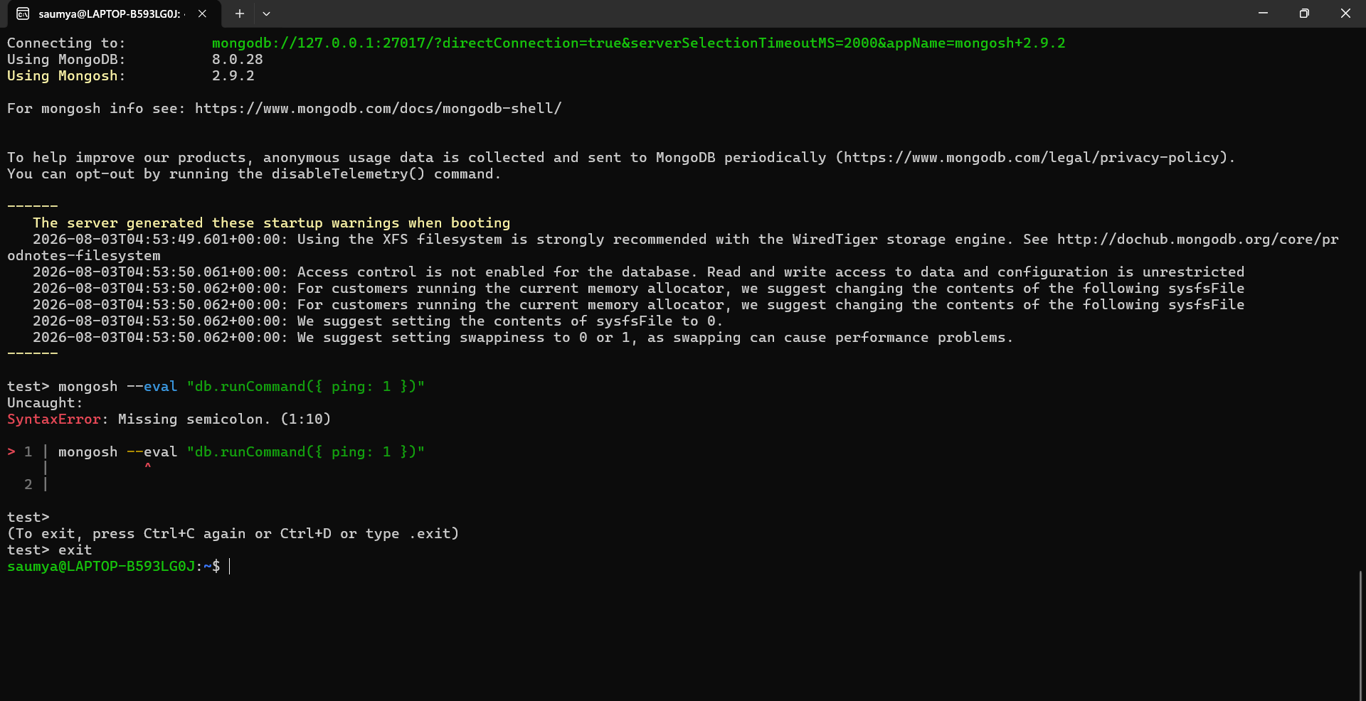

PART 2: Neo4j Installation in WSL (10 minutes)
Step 2.1: Install Java (Required for Neo4j)
bash
sudo apt install openjdk-17-jre-headless -y
Step 2.2: Verify Java Installation
bash
java -version
Expected Output: openjdk version "17.x.x"
Step 2.3: Import Neo4j GPG Key
bash
wget -O - https://debian.neo4j.com/neotechnology.gpg.key | sudo gpg --dearmor -o
/etc/apt/keyrings/neotechnology.gpg
Step 2.4: Add Neo4j Repository
bash
echo 'deb [signed-by=/etc/apt/keyrings/neotechnology.gpg] https://debian.neo4j.com
stable latest' | sudo tee /etc/apt/sources.list.d/neo4j.list
Step 2.5: Update and Install Neo4j
bash
sudo apt update
sudo apt install neo4j -y
Step 2.6: Start Neo4j Service
bash
sudo service neo4j start
Step 2.7: Verify Neo4j is Running
bash
sudo service neo4j status
Expected Output: active (running)
Step 2.8: Configure Neo4j for Browser Access
By default, Neo4j binds to localhost. Check if it's accessible:
bash
sudo cat /etc/neo4j/neo4j.conf | grep bolt
Step 2.9: Access Neo4j Browser
1. Open your Windows browser
2. Go to: http://localhost:7474
3. Login with:
o Username: neo4j
o Password: neo4j
4. You will be prompted to change password. Set it to: password123
5. Keep this browser tab open for Part 4

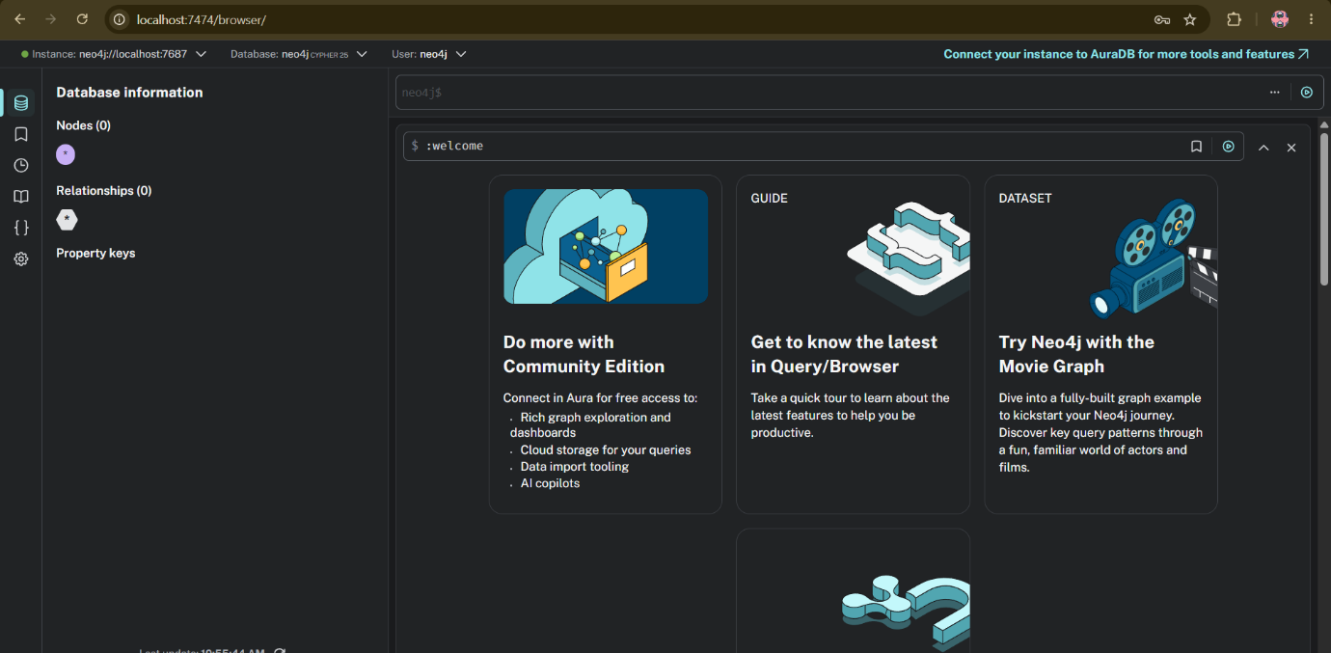

db.students.find({student_id: "S001"}).explain("executionStats")
3.9 Exit MongoDB
javascript
exit
PART 4: Neo4j Hands-On Exercise (40 minutes)
4.1 Access Neo4j Browser
1. Open your browser to: http://localhost:7474
2. Login with: neo4j / password123
3. You should see the Neo4j browser interface with a command input
4.2 Create Nodes (Students and Courses)
a) Create Student Nodes
cypher
CREATE (a:Student {id: 'S001', name: 'Alice Johnson', email: 'alice@example.com'})
CREATE (b:Student {id: 'S002', name: 'Bob Smith', email: 'bob@example.com'})
CREATE (c:Student {id: 'S003', name: 'Carol White', email: 'carol@example.com'})
CREATE (d:Student {id: 'S004', name: 'David Brown', email: 'david@example.com'})
CREATE (e:Student {id: 'S005', name: 'Eva Green', email: 'eva@example.com'})
b) Create Course Nodes
cypher
CREATE (c1:Course {id: 'C101', title: 'Python for Data Science', instructor: 'Dr. Mehta'})
CREATE (c2:Course {id: 'C102', title: 'Machine Learning Basics', instructor: 'Prof. Gupta'})
CREATE (c3:Course {id: 'C103', title: 'Web Development', instructor: 'Dr. Shah'})
CREATE (c4:Course {id: 'C104', title: 'Cloud Computing', instructor: 'Prof. Reddy'})
4.3 Create Relationships
a) Enrollments
cypher
MATCH (a:Student {id: 'S001'}), (c1:Course {id: 'C101'})
CREATE (a)-[:ENROLLED_IN {progress: 75, status: 'in-progress'}]->(c1)
MATCH (a:Student {id: 'S001'}), (c2:Course {id: 'C102'})
CREATE (a)-[:ENROLLED_IN {progress: 100, status: 'completed'}]->(c2)
MATCH (b:Student {id: 'S002'}), (c1:Course {id: 'C101'})
CREATE (b)-[:ENROLLED_IN {progress: 40, status: 'in-progress'}]->(c1)
MATCH (c:Student {id: 'S003'}), (c2:Course {id: 'C102'})
CREATE (c)-[:ENROLLED_IN {progress: 100, status: 'completed'}]->(c2)
MATCH (d:Student {id: 'S004'}), (c3:Course {id: 'C103'})
CREATE (d)-[:ENROLLED_IN {progress: 10, status: 'not-started'}]->(c3)
MATCH (e:Student {id: 'S005'}), (c1:Course {id: 'C101'})
CREATE (e)-[:ENROLLED_IN {progress: 20, status: 'not-started'}]->(c1)
MATCH (e:Student {id: 'S005'}), (c3:Course {id: 'C103'})
CREATE (e)-[:ENROLLED_IN {progress: 60, status: 'in-progress'}]->(c3)
b) Follows Relationships
cypher
MATCH (a:Student {id: 'S001'}), (b:Student {id: 'S002'})
CREATE (a)-[:FOLLOWS]->(b)
MATCH (a:Student {id: 'S001'}), (c:Student {id: 'S003'})
CREATE (a)-[:FOLLOWS]->(c)
MATCH (a:Student {id: 'S001'}), (e:Student {id: 'S005'})
CREATE (a)-[:FOLLOWS]->(e)
MATCH (b:Student {id: 'S002'}), (a:Student {id: 'S001'})
CREATE (b)-[:FOLLOWS]->(a)
MATCH (b:Student {id: 'S002'}), (d:Student {id: 'S004'})
CREATE (b)-[:FOLLOWS]->(d)
MATCH (c:Student {id: 'S003'}), (a:Student {id: 'S001'})
CREATE (c)-[:FOLLOWS]->(a)
MATCH (c:Student {id: 'S003'}), (d:Student {id: 'S004'})
CREATE (c)-[:FOLLOWS]->(d)
MATCH (c:Student {id: 'S003'}), (e:Student {id: 'S005'})
CREATE (c)-[:FOLLOWS]->(e)
MATCH (d:Student {id: 'S004'}), (b:Student {id: 'S002'})
CREATE (d)-[:FOLLOWS]->(b)
MATCH (e:Student {id: 'S005'}), (a:Student {id: 'S001'})
CREATE (e)-[:FOLLOWS]->(a)
MATCH (e:Student {id: 'S005'}), (c:Student {id: 'S003'})
CREATE (e)-[:FOLLOWS]->(c)
4.4 Query Operations
a) Get All Students
cypher
MATCH (s:Student) RETURN s
b) Get All Courses
cypher
MATCH (c:Course) RETURN c
c) Get Alice's Enrolled Courses
cypher
MATCH (a:Student {id: 'S001'})-[e:ENROLLED_IN]->(c:Course)
RETURN a.name, c.title, e.progress, e.status
d) Get All Students Enrolled in Course C101
cypher
MATCH (s:Student)-[e:ENROLLED_IN]->(c:Course {id: 'C101'})
RETURN s.name, e.progress, e.status
e) Get Students Following Alice
cypher
MATCH (f:Student)-[:FOLLOWS]->(a:Student {id: 'S001'})
RETURN f.name, f.email
f) Get Who Alice is Following
cypher
MATCH (a:Student {id: 'S001'})-[:FOLLOWS]->(f:Student)
RETURN f.name, f.email
4.5 Advanced Queries
a) Get Course Recommendations for Alice
Find courses that Alice's followers are enrolled in but Alice is not:
cypher
MATCH (alice:Student {id: 'S001'})
MATCH (alice)-[:FOLLOWS]->(follower:Student)
MATCH (follower)-[:ENROLLED_IN]->(course:Course)
WHERE NOT (alice)-[:ENROLLED_IN]->(course)

RETURN DISTINCT course.title, course.instructor
b) Find Mutual Followers
cypher
MATCH (s1:Student)-[:FOLLOWS]->(s2:Student)
MATCH (s2)-[:FOLLOWS]->(s1)
RETURN s1.name, s2.name
c) Find Shortest Path from Alice to David
cypher
MATCH p=shortestPath(
(a:Student {id: 'S001'})-[*]-(d:Student {id: 'S004'})
)
RETURN p
d) Find Students with Completed Courses
cypher
MATCH (s:Student)-[e:ENROLLED_IN]->(c:Course)
WHERE e.status = 'completed'
RETURN s.name, c.title, e.progress
e) Count Followers for Each Student
cypher
MATCH (f:Student)-[:FOLLOWS]->(s:Student)
RETURN s.name, COUNT(f) AS followers_count
ORDER BY followers_count DESC
f) Get Course Enrollment Statistics
cypher
MATCH (s:Student)-[e:ENROLLED_IN]->(c:Course)
RETURN c.title, COUNT(s) AS total_students, AVG(e.progress) AS avg_progress
4.6 Update Operations
a) Update Alice's Progress
cypher
MATCH (a:Student {id: 'S001'})-[e:ENROLLED_IN]->(c:Course {id: 'C101'})
SET e.progress = 95, e.status = 'completed'
RETURN a.name, c.title, e.progress, e.status
b) Add New Student with Enrollment
cypher
CREATE (f:Student {id: 'S006', name: 'Frank Lee', email: 'frank@example.com'})
WITH f
MATCH (c:Course {id: 'C104'})
CREATE (f)-[:ENROLLED_IN {progress: 0, status: 'not-started'}]->(c)
RETURN f.name, c.title
c) Add Follow Relationship
cypher
MATCH (f:Student {id: 'S006'}), (a:Student {id: 'S001'})
CREATE (f)-[:FOLLOWS]->(a)
RETURN f.name, a.name
4.7 Delete Operations
a) Delete a Student
cypher
MATCH (s:Student {id: 'S005'})
DETACH DELETE s
b) Delete a Relationship
cypher
MATCH (s:Student {id: 'S001'})-[e:ENROLLED_IN]->(c:Course {id: 'C102'})
DELETE e
c) Delete All Data (Warning: Irreversible)
cypher
MATCH (n) DETACH DELETE n
4.8 View the Graph
a) View Entire Graph
cypher
MATCH (n) RETURN n LIMIT 100
b) View Specific Subgraph (Alice and her connections)
cypher
MATCH (a:Student {id: 'S001'})-[*1..2]-(connected)
RETURN a, connected
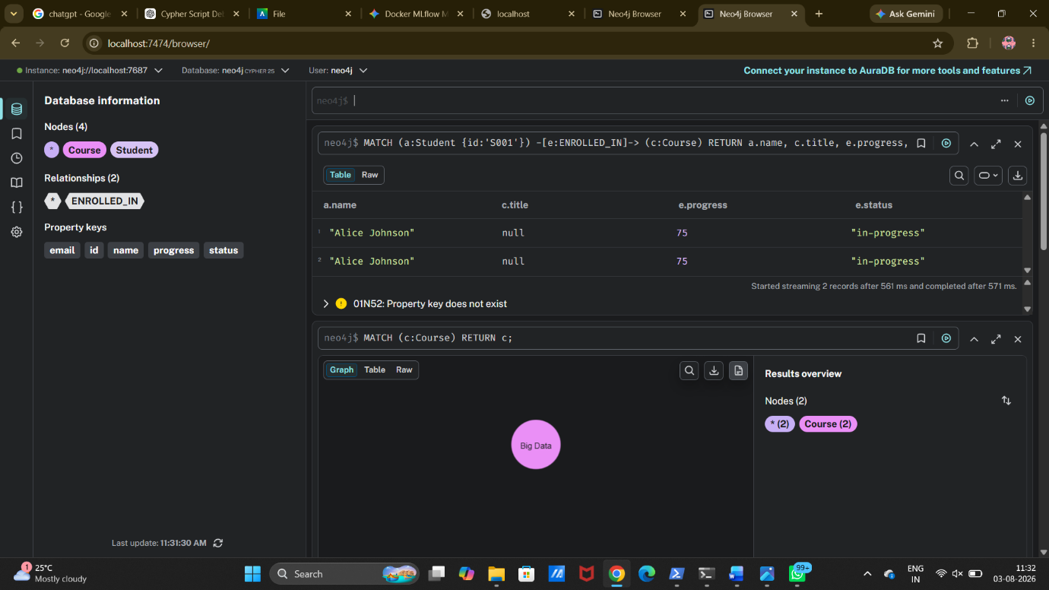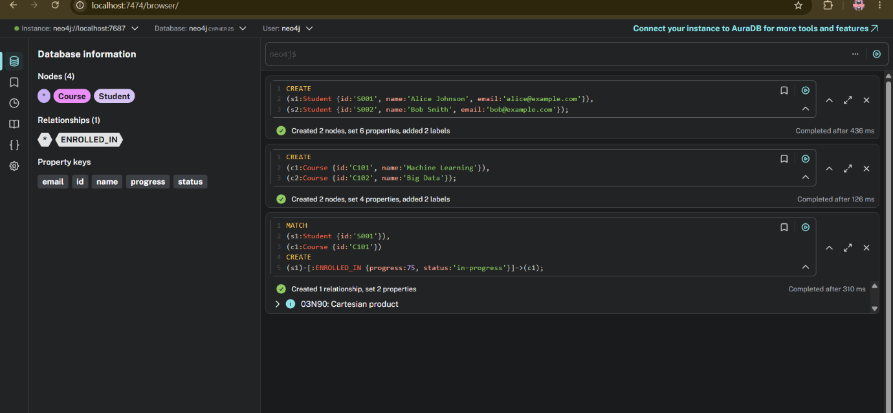
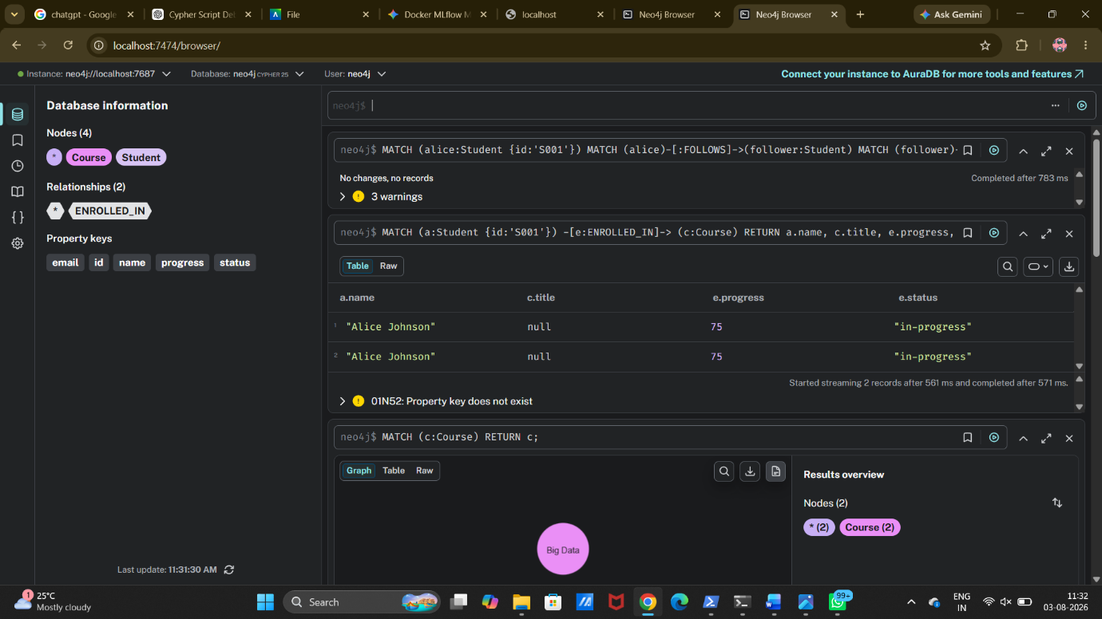

Conclution:
The Neo4j graph database experiment successfully demonstrated the modeling and management of a student learning network using nodes, relationships, and properties. Student and course entities were represented as nodes, while ENROLLED_IN and FOLLOWS relationships captured academic participation and social connections between students.
Using Cypher queries, various graph operations were performed, including data retrieval, relationship traversal, recommendation generation, shortest path analysis, aggregation, updating, and deletion of graph elements. The experiment showed that graph databases efficiently handle highly connected data and provide faster relationship-based querying compared to traditional relational approaches.
The advanced queries demonstrated the ability of Neo4j to identify patterns such as course recommendations, mutual followers, completed courses, and enrollment statistics. Overall, the experiment provided practical understanding of graph data modeling, Cypher query language, and Neo4j operations for managing connected data applications such as e-learning platforms and social networks.

